**Activity 2: MQL Query Practice**Connect to your MongoDB Atlas cluster using MongoDB Compass.

Choose an existing database and collection to work with or create a new database and

collection. 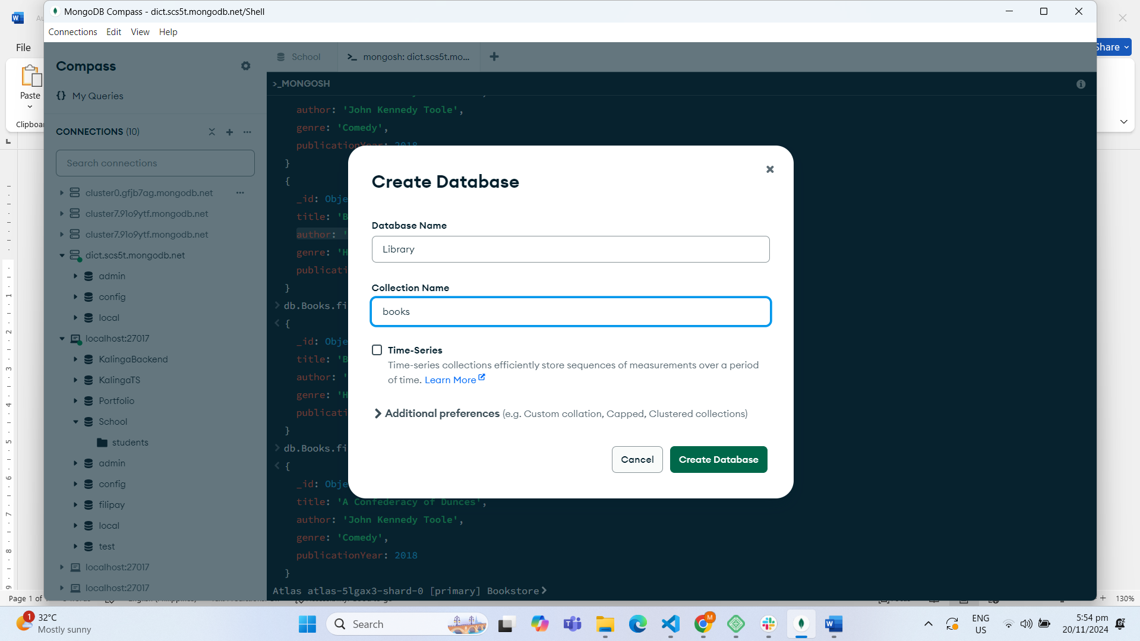

**Inserted Books  
  
**

**a) Retrieve all documents from the collection.**

**b) Retrieve documents where the genre is "Romance".  
  
**

**c) Retrieve documents where the publication year is greater than 1950.  
**

**d) Retrieve documents where the author's name starts with "J".**

**e) Retrieve documents where the title contains the word "the".**source: <https://stackoverflow.com/questions/41836552/how-to-find-all-documents-with-only-looking-at-first-letter-of-the-values-in-mon/41837034> 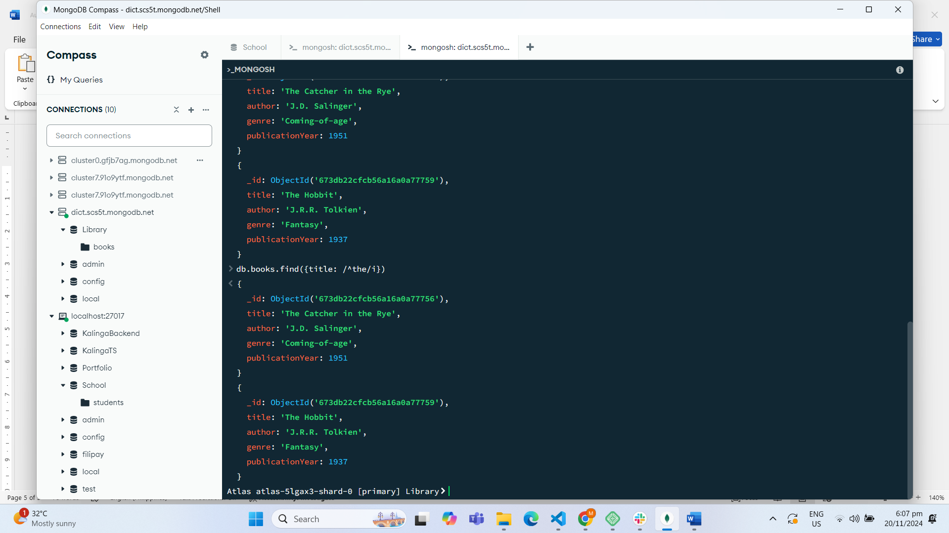

**DROP DATABASE  
  
**